Information for incoming students

Courses at Faculty of Arts and Humanities
Subjects are taught in Spanish, except the specific Languages´ courses, which are taught in the respective Language.
A full academic year consists of 60 ECTS. 1 Spanish credit = 10 hours (lectures or laboratory, mastered by a teacher). Courses can be:
- "Anual": the whole academic year.
- "Cuatrimestral": Only one period or term.
  - "Primer cuatrimestre" or "cuatrimestre 1" (1st term) will start in the end-September or beg-October and will finish in mid-February (including exams).
  - "Segundo cuatrimestre" or "cuatrimestre 2" (2nd term) will start in mid-February and will finish in mid-July (including exams).
The available courses are these:
http://filosofiayletras.ugr.es/pages/docencia/grados
You can see the timetable in this site:
http://filosofiayletras.ugr.es/pages/docencia/horarios/grados_horarios
You can also choose any module from the Catálogo de Libre Configuración (free configuration catalogue). These are subjects from any of the degrees offered at the Universidad de Granada. Keep in mind that these subjects have a limited number of seats, so, it can be complete if you register too late.

Grading system
Most of the subjects offered at our faculty have a double examination systems; theoretical test and course works.
The first is a written exam based on the theory given in the lectures. The course works are, in most of the cases, compulsory and the student must do them by himself or in group.
The value of any of these parts depend on the subjects. The qualification systems will give a mark between 0.0 and 10.0 and the student must get more than 5.0 to pass the course:
MARK | GRADE | ECTS GRADE
10.0 (only 5% of the whole) | MATRICULA DE HONOR | A+ EXCELLENT
9.0-10.0 | SOBRESALIENTE | A EXCELLENT
8.0-8.9 | NOTABLE | B VERY GOOD
7.0-7.9 | NOTABLE | C GOOD
6.0-6.9 | APROBADO | D SATISFACTORY
5.0-5.9 | APROBADO | E PASS
0.0-4.9 | SUSPENSO | F FAIL
 | NO PRESENTADO | Did not take the exam

If a student passes the subject (theoretical + practical), then gets the number of ETCS associated to the subject.

Online Application is compulsory for incoming students:
http://internacional.ugr.es/pages/perfiles/estudiantes/estudiantes_int
http://internacional.ugr.es/pages/perfiles/estudiantes/procedimientosolicitudonlineerasmus?lang=en

Buddy Programme o Programa Mentor para Estudiantes Internacionales de la UGR
http://internacional.ugr.es/pages/perfiles/estudiantes/nuevas-iniciativas-para-estudiantes-internacionales

What to do on arriving in Granada

- One of the first things you have to do once you are in Granada is attend the Reception Meetings for international students organised by the UGR International Relations Office.
All the information about it will be published the previous week to the beginning of each semester in our web site: http://internacional.ugr.es

http://internacional.ugr.es/pages/movilidad/estudiantes/entrantes/jornadas-incoming

http://internacional.ugr.es/pages/movilidad/estudiantes/entrantes/orientation-week/serviciosjornadasrecepcion_curso1314

After the Meeting, if you still have any question, you can contact the International Relations Office (ORI) of the University of Granada (UGR) which is located at Cuesta del Hospicio s/n, 18071 Granada. Office hours: from 09:00 am to 14:00 pm from Monday to Friday.

You will need to bring with you a copy of your online application, a copy of your passport or ID card and a passport-size photo (if you did not upload one when applying online). On handing in these documents we will proceed to prepare your student card, which can be picked up at the Faculty or School where you will be following courses. With this card you can register for courses and use the various student services offered by the University.

- Library: http://biblioteca.ugr.es/?lang=en
- Sport Service (ask for your Sport card): http://www.cadugr.es/
- Computer Services: Wi-fi connexion, e-mail, etc. http://www.ugr.es/informatica/alumnos/infalumnos.htm
- Refectory: http://www.ugr.es/~scu/

GOVERNMENT OF SPAIN: COMPULSORY ADMINISTRATIVE PROCEDURES FOR FOREIGNERS

http://internacional.ugr.es/pages/movilidad/estudiantes/entrantes/residenciainspain

- Registration At The Faculty

The Faculty or School where you are going to study will inform you of what you need to do to register for courses and when. All queries to do with the academic side of your study period should be dealt with through the International Relations Office at your Faculty or School.

Important: Enrolment on the courses specified in the academic agreement is subject to the availability of places in the corresponding Centre.
After you have registered, you’ll receive a password (PIN) that enables you to login to the Virtual Secretary’s Office. Once logged in, you’ll be able to access your academic information.

LEARN LANGUAGES!! Without a doubt, studying in Spanish and knowing Spanish will open
many doors for you in your future career. There are over 21 million students of Spanish worldwide, it is second only to English as a foreign language and it has been integrated into education systems in, for example, the USA and Brazil.

You may well be interested in the Spanish language and culture courses run by the UGR Modern Languages Centre (CLM). But don't forget that the CLM also organises courses in other foreign languages: Arabic, Catalan, Chinese, English, French, German, Italian, Japanese, Portuguese, Russian and Swedish. http://www.clm-granada.es

ACCOMMODATION
The UGR offers information about the available options for accommodation in Granada. This service is available through the link: http://estudiantes.ugr.es/alojamiento/
La Oficina de Gestión de Alojamientos de la UGR (accommodation service at UGR) will help you to find accommodation during your stay at UGR. You'll get information about availability in the residences and private flats to rent. Since Granada receives thousands of students there are a lot of apartments available to share with other students. We are sure you will not have problems in finding a good place to live.
E-Mail: alojamiento@ugr.es
Phone: +34 958 244 072
Fax: +34 958 243 134
Address: Edificio Comedores Universitarios
C/ Severo Ochoa s/n
18071 Granada

The website http://www.erasmate.com focuses on (international) student-to-student housing for short term periods and can be used for free by incoming and outgoing students.
That link could help to outgoing students in sub-letting their room for a short term and to incoming students with finding their housing more easily.

HEALTH INSURANCE
Our institutions will provide assistance in obtaining insurance for incoming and outgoing students/staff according the requirements of the Erasmus Charter of Higher Education.
http://ec.europa.eu/education/lifelong-learning-policy/ects__en.htm

We will inform incoming students/staff of cases in wich insurance cover is not automatically provided. Information and assistance can be provided by the following contact points and information sources:

Contact details | International Relations and Development Cooperation Office  e-mail: intlinfo@ugr.es  Tel: +34 958 249 030

VISA
Our institution will provide assistance, when required, in securing visas for incoming and outgoing students/staff, according to the requirements of the Erasmus Charter for Higher Education. Information and assistance can be provided by the following contact points and information sources:

Contact details | International Relations and Development Cooperation Office  e-mail: intlinfo@ugr.es  Tel: +34 958 249 030
Website | http://internacional.ugr.es/pages/movilidad/estudiantes/entrantes/residenciainspain

CALENDARIO ACADÉMICO/ ACADEMIC YEAR CALENDAR
You can find the academic year calendar of the UGR at:

http://www.ugr.es/pages/estudios/calendario

Here there are some other useful links and contact details that can help you plan your stay at the UGR:
International Relations Office of the UGR:
http://internacional.ugr.es/
Tlf.: +34 958 249 030, Fax: +34 958 243 009. E-mail: intlinfo@ugr.es

International Student Guide:
http://internacional.ugr.es/pages/archivos/informacion/guiapdf

Modern Languages Centre (Information about Spanish Language Courses and other Languages):
http://www.ugr.es/~clm/indexesp.htm

Granada: information about the city, web of Granada’s Town Hall: http://www.granada.org/

UGR’s Foreign Students Association. E-mail: asee@ugr.es

Casa de Porras (UGR’s centre for workshops and cultural activities): http://www.ugr.es/~ccucp/

To look for general information about Faculties you can check their site through this link:
http://www.ugr.es/ugr/index.php?page=centros

HOW TO GET HERE
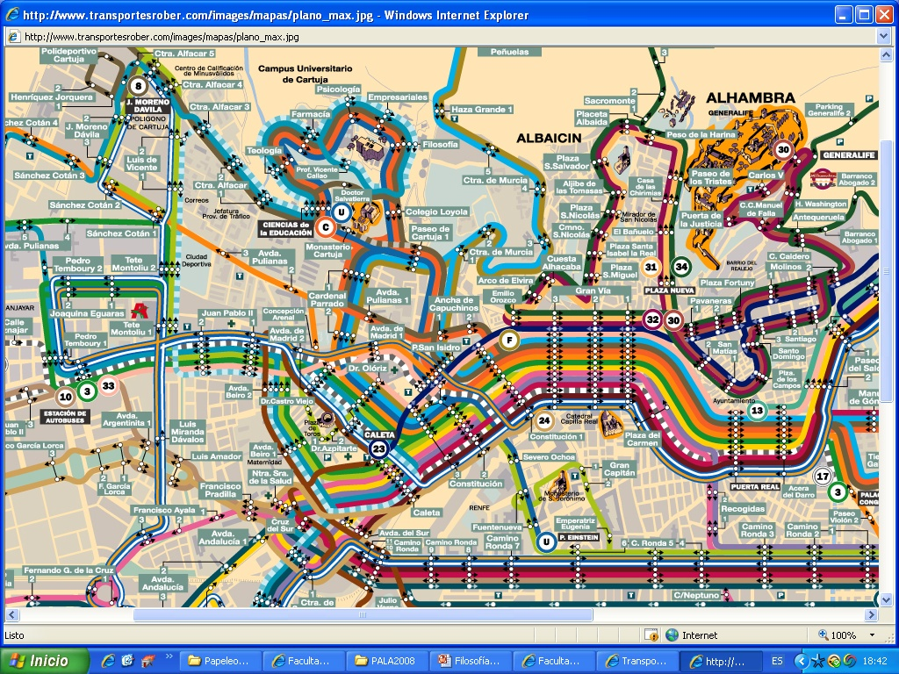

From La Chana: 20 and 20D
From El Zaidín and Nueva Granada: 8
From El Palacio de Deportes: C
From El Campus de Ciencias: U
From Cartuja: 8, 20 and 20D

OUR SERVICES

- Conserjería/Reception
  - Monday-Friday, 08:00 - 21.30 h.
  - Saturdays, 09:00 – 13:30 h.
http://filosofiayletras.ugr.es/pages/servicios/conserjeria

- Biblioteca/Library:
  - Monday-Friday, 08:00 - 20.30 h.
  - Préstamo / Book lending
  - Biblioteca digital / E-library (VPN)
http://filosofiayletras.ugr.es/pages/biblioteca

- Videoteca/Video Library
  - Monday-Friday, 10:00 – 14:00 h. and 15:00 – 19:00 h.
http://filosofiayletras.ugr.es/pages/servicios/videoteca

- Audioteca/Music Library
  - Monday-Friday, 09:00 – 14:00 h.

- Sala de ordenadores/Computer Room
  - Monday-Friday depending on lessons
http://filosofiayletras.ugr.es/pages/servicios/aulas_informatica

- Fotocopiadora/Photocopy Room
  - Monday-Friday, 09:00 – 14:00 h. and 16:00 – 20:00 h.
http://filosofiayletras.ugr.es/pages/servicios/reprografia

- Comedores Universitarios / Refectory
  - Cafetería de la Facultad /School Cafeteria
  - Residencia / Hall Carlos V
  - Campus Fuente Nueva
  - Cartuja
http://cafeteriafilosofia.es/
http://www.ugr.es/~scu/

INTERNATIONAL OFFICE

- Contact
Web: http://filosofiayletras.ugr.es/pages/servicios/relacionesinternacionales/index
Email: incoletras@ugr.es
Tel: +34 958 248 956 // +34 958 241 000 (Ext. 20104)
Fax: +34 958 243 561

- Office hours
Monday to Friday, 10:30 – 13:00 h.

- Vicedean for International Relations
Nobuo Ignacio López Sako (incoletras@ugr.es )

- Staff
Administrative staff
- Ana María López Morales
- Nuria Estivill Figuerola
- Juan Ramón Sánchez Alquiza

We are very grateful for your cooperation.
Best regards

Nobuo Ignacio López Sako
Vice-dean for International Relations

